Case 2-Afr-Egy-Statue-Ptah-Chlorite-Dynasty 18-1390-1322 BCE
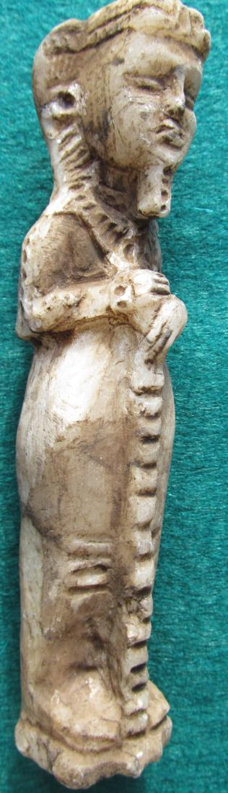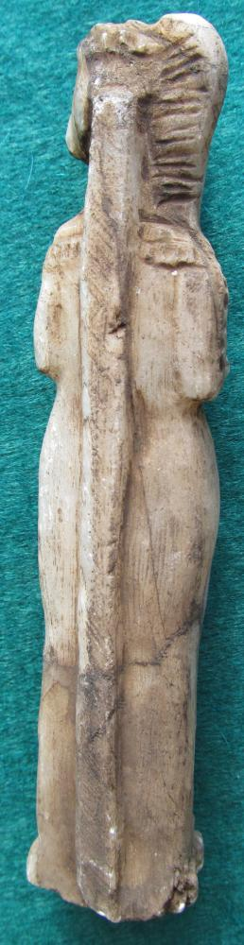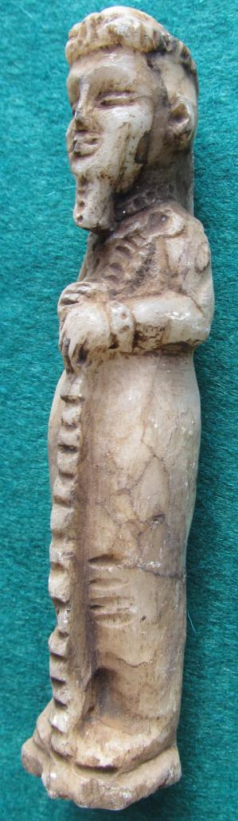

Figurine of Ptah, Memphis, Dynasty 18, reign of Amenhotep III - Tutankhamun (1390-1322 BCE)
BL2450.P7
Statuette of Ptah
Height:
Weight:

Ptah, god of craftsmen, was father of Nefertum and Imhotep. Nefertum was represented both the first sunlight and the emerging blue lotus flower (Nymphaea caerulea) from the primal waters. Imhotep was regarded also as the god of craftsmen and architects (a knowledge passed on from Ptah) and who was subsequently regarded as the earliest known architect and engineer in history. Imhotep was king Djoser’s architect of the Step Pyramid, which was built ca. 2650–2600 BCE, and he was also high priest of the sun god Ra at Heliopolis. Ptah’s wife was Sekhmet the lioness-headed goddess. Here, Ptah is shown wearing a beard (divine symbol) and a single braid on his right side. He holds the djed, perhaps in this case an instrument of measurement as it is prominently grooved horizontally. Perhaps, this statuette was once the amulet of an Egyptian engineer. As the god of craftsmen, the Ptah cult spread throughout Egypt from the Old Kingdom onwards.

References
Kemp, Barry J. 2005. Ancient Egypt. London: Routledge.
Holmberg, Sandman. 1946. The God Ptah. Lund: C.W.K. Gleerup .

Ralph J Coffman Jr
149 Atlantic Ave
Swampscott MA 01907-2427
United States

Order details
Item title | Available actions | Shipping & handling (estimated delivery*) | Price
Printer version
Seller: | Member id antiquewd ( Feedback Score Of 1459) | Contact seller

Order # 125303748018
Paid on Nov-18-12 via PayPal
antiquewd
Member id antiquewd | Feedback Score Of 1459 | 98.5%
Total items : 17
$541.62
+$40.00
shipping
More actions
Egyptian stone style statue figure
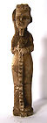
Egyptian stone style statue figure (271104337269)
Your max bid: $66.00
Sale date: 11/18/12
Tracking number: --
Estimated Delivery: 11/21/12 - 11/26/12
$20.50
Paid with PayPal on November 18, 2012.
Not shipped
Feedback not left
Feedback not received
Leave feedback
Sell this item
More actions

